Date | 15 February 2025
Team ID | SWTID-2026-7028
Project Name | Implement Client Script & UI Policy (Incident)
Maximum Marks | 4 Marks

Solution Architecture
The solution uses a ServiceNow Client Script to automatically set the Urgency field when the Impact field on an Incident is changed to High. The script is configured as an active onChange Client Script on the Incident table and uses g_form to update the form and display an informational message.
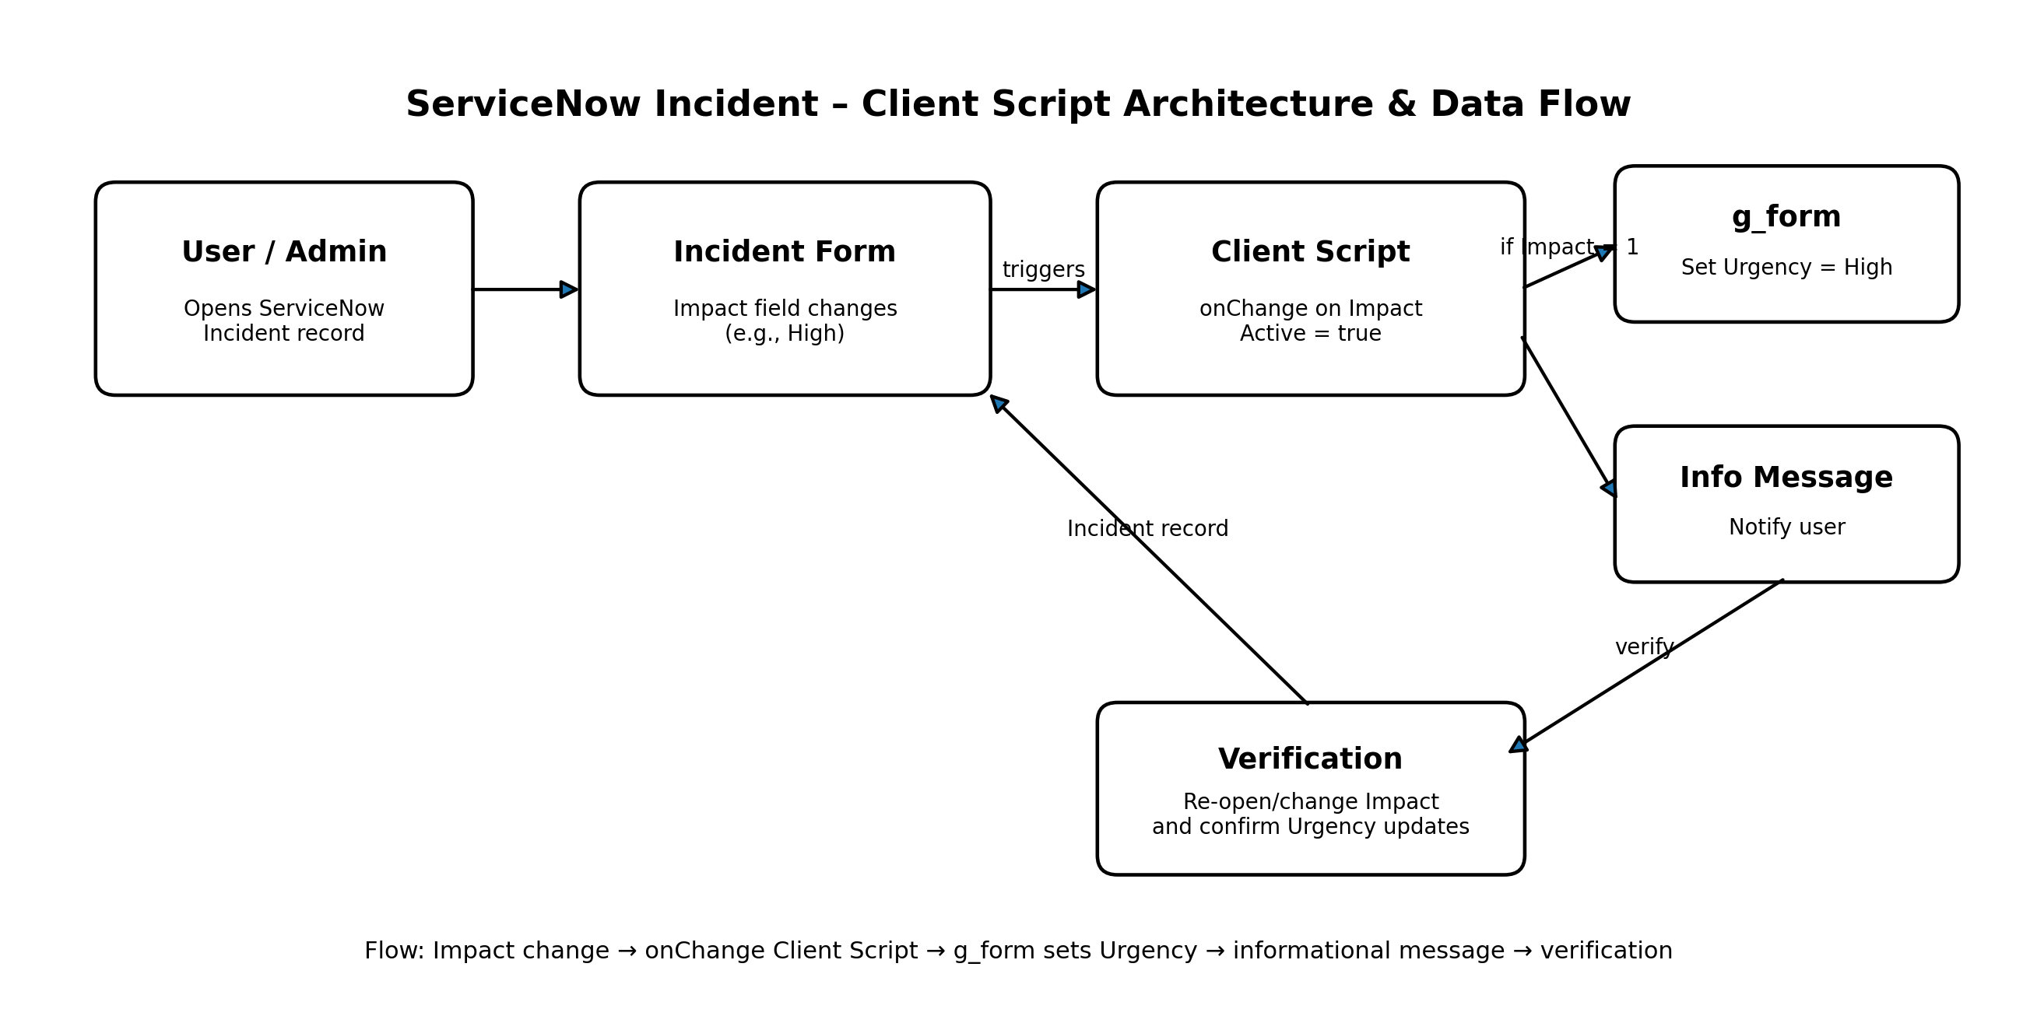
Figure 1: Architecture and data flow of the ServiceNow Incident Client Script

Client Script Configuration
1. Navigate to Client Scripts: Go to System UI → Client Scripts.
2. Create a new Client Script: Click New to create a new Client Script.
3. Fill in the details:
• Name: Auto set urgency for high impact – clearly shows the purpose.
• Table: Incident – the script runs only on Incident records.
• Type: onChange – executes when a field value changes.
• Field name: Impact – triggers the script when Impact is updated.
• Active: true – ensures the script runs immediately.
4. Paste the script in the script editor section:
function onChange(control, oldValue, newValue, isLoading) {
if (isLoading || newValue == '') {
return;
}
if (newValue == '1') {
g_form.setValue('urgency', '1');
g_form.addInfoMessage('Urgency set to High for High impact incident.');
}
}
5. Click Submit: Click Submit to save the Client Script.
6. Verify: Open an Incident record and change the Impact field to High. The Urgency field should update automatically.
7. Submit: Click Submit.

Architecture Flow
• User changes the Impact field on an Incident record.
• The onChange Client Script is triggered by the Impact field change.
• If the new Impact value is High ('1'), g_form.setValue() sets Urgency to High ('1').
• g_form.addInfoMessage() informs the user that Urgency has been set to High.
• The user verifies the automatic update and submits the Incident record.
Reference: User-provided Client Script instructions and architecture requirements.

